Website Audit | Perfect Balance Health

1. What the Website Is
Perfect Balance Health is a hormone therapy and wellness clinic based in San Diego, California, offering bioidentical hormone replacement therapy (HRT), weight management, longevity support, and telemedicine services. The practice emphasizes holistic, personalized care for adults of all genders with hormone imbalances and related symptoms like fatigue, weight gain, low libido, and aging concerns.
The homepage markets services and shows patient testimonials, while an About Us section describes the mission and team.

2. Overall Website Structure
Main Navigation Includes:
- Services (Women’s Hormones, Men’s Hormones, Weight Loss, Longevity)
- How It Works
- Resources (Blog/Articles)
- About Us (Team, Dr. Gray, Media)
- FAQ
- Contact & Patient Portal
- Book Now CTA

3. Design & User Experience

Strengths
✔ Clean and clear layout with simple menus.
✔ Uses real patient testimonials on the homepage.
✔ Team pages provide a personal touch.

Issues / Opportunities
⚠ Visual hierarchy could improve: The homepage shows testimonials before service details, which may confuse new visitors.
⚠ Primary CTA (“Get Started” / “Book Now”) is not visually prominent enough, especially above the fold.
⚠ Key information like pricing and specific service details are scattered or absent.

4. Content Quality & Messaging

Strengths
✔ Content clearly reinforces the clinic’s mission to treat hormonal imbalances.
✔ Includes professional bios of medical staff.

Weaknesses
⚠ Content is very high-level and promotional; it lacks deeper educational value (e.g., scientific background, evidence, conditions treated, expected outcomes).
⚠ Patient cases or procedure explanations are missing or minimal (other than testimonials).
⚠ Blog/articles exist, but they seem more like general content and not tied directly to conversion or SEO strategy.

5. SEO (Search Engine Optimization)

Strengths
✔ Pages have a clear focus on hormone therapy topics.

Weaknesses
⚠ Meta titles/descriptions and page headers are not optimized for search intent (e.g., “San Diego hormone therapy clinic”).
⚠ Internal linking between services and educational content is weak, limiting SEO depth.
⚠ There is no structured data markup visible for doctors, services, or location (schema markup improves search presence).
⚠ The site lacks long-form educational content with keyword targeting to attract organic traffic.

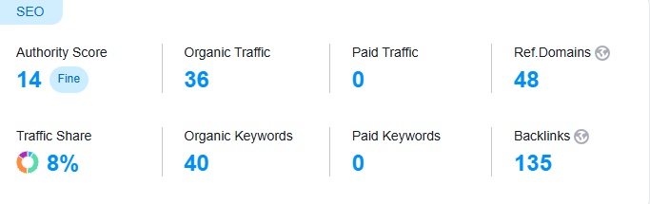

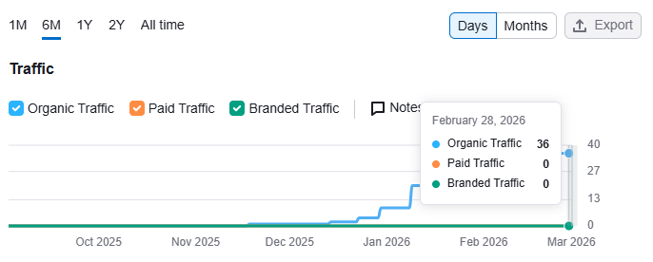

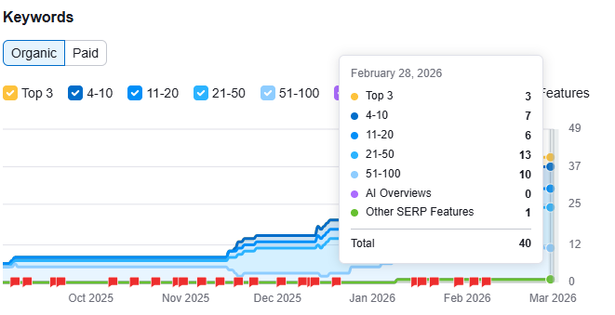

6. AI Visibility
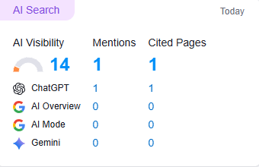

7. Technical Performance & Mobile Experience

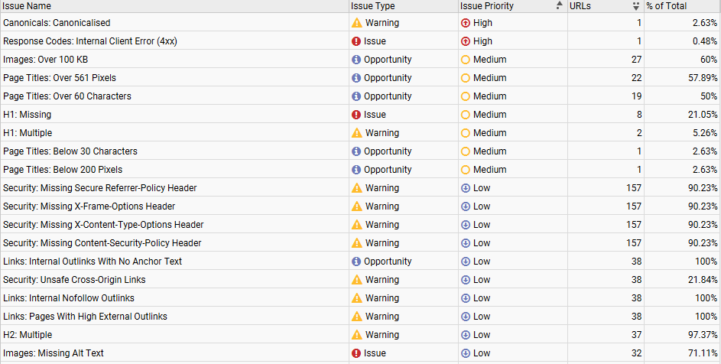

8. Summary Score (High-Level)
Category | Rating
Content Quality | ⭐⭐☆☆☆
SEO Optimization | ⭐⭐☆☆☆
User Experience | ⭐⭐⭐☆☆
Conversion Optimization | ⭐⭐☆☆☆
Trust & Credibility | ⭐⭐☆☆☆
Technical Performance | ⭐⭐⭐☆☆

Key Highlights:
1. Core Service Keywords (High-Intent / Revenue Keywords)
These are the ones that bring actual patients.

Primary Commercial Keywords
- Hormone replacement therapy
- Bioidentical hormone replacement therapy
- BHRT near me
- Hormone doctor near me
- Hormone therapy clinic
- Menopause hormone therapy
- Perimenopause treatment
- Testosterone therapy for women
- Testosterone therapy for men
- Naturopathic hormone doctor
- Functional medicine hormone specialist
- Integrative hormone therapy

Geographic Modifiers (CRITICAL)
Since she’s in San Diego, you need:
- Hormone replacement therapy San Diego
- BHRT San Diego
- Menopause specialist San Diego
- Naturopathic doctor San Diego hormones
- Integrative medicine San Diego hormones
👉 These are likely your most valuable SEO targets.

2. Symptom-Based Keywords (High Search Volume)
These convert extremely well because people Google symptoms first.

Menopause / Perimenopause
- Naturopathic treatment for hot flushes
- Natural treatment for hot flashes
- How to stop night sweats
- Hormones for anxiety menopause
- Brain fog menopause treatment
- Menopause weight gain treatment
- Hormone imbalance symptoms in women
- Best treatment for perimenopause

Men’s Hormone Issues
- Low testosterone symptoms
- TRT near me
- Natural testosterone therapy
- Hormone imbalance in men
- Andropause treatment

Weight + Longevity
- Hormones and weight loss
- Why can’t I lose weight after 40
- Bioidentical hormones and weight loss
- Longevity clinic near me
- Anti-aging hormone therapy

3. Authority + Media Keywords (Podcast/Video Strategy)
Since she’s big on podcasts and speaking, this is where she can dominate.

Personal Brand Keywords
- Dr Janette Gray hormone therapy
- Dr Gray menopause expert
- Hormone doctor podcast
- Menopause podcast expert guest
- Hormone therapy speaker

Video/YouTube Keywords
- Does hormone replacement therapy cause cancer?
- Is BHRT safe?
- Progesterone vs estrogen explained
- What doctors don’t tell you about menopause
- Signs you need hormone therapy
- Why your hormones are out of balance
These are PERFECT for short AI-assisted video clips.

4. AI Video Strategy (This is where she can win big)
Since she already does podcasts:

Step 1: Clip Extraction
Take long podcast interviews and:
- Cut into 30–90 second clips
- Add subtitles
- Add branded intro/outro
- Add CTA (“Book a consult in San Diego”)
AI tools can:
- Auto-generate captions
- Auto-write hooks
- Create highlight reels
- Generate blog posts from transcripts
- Create YouTube descriptions with SEO keywords

Step 2: AI Content Multiplication System
From ONE podcast episode:
Asset | Created By
5–10 Reels | AI clip detection
1 SEO blog post | Transcript → optimized article
4 LinkedIn posts | Key quotes
5 FAQ | Extracted Q&A
1 Email newsletter | Episode summary
YouTube SEO description | Keyword optimized
This creates omnipresence.

5. Competitive Positioning
She is competing against:
- Large telehealth hormone clinics
- Functional medicine doctors
- Menopause influencers
- Biohacking longevity brands
Her advantage:
✔ Real clinic
✔ Medical authority
✔ Local presence
✔ Media experience
But she must:
- Increase SEO authority
- Improve conversion funnels
- Increase YouTube + short-form video presence

6. If You Want Quick Wins
If you only have limited time/resources, do this:
- Optimize homepage for:
  - Hormone replacement therapy San Diego
  - Bioidentical hormone therapy San Diego
- Create 5-7 blog posts around:
  - Naturopathic treatment for hot flushes
  - Is hormone therapy safe?
  - Progesterone benefits
  - Testosterone therapy for women
- Launch YouTube channel optimized for:
  - Menopause education
  - Hormone myths
  - Short-form clips from podcasts
- Add schema markup for:
  - Local business
  - Physician
  - FAQ

